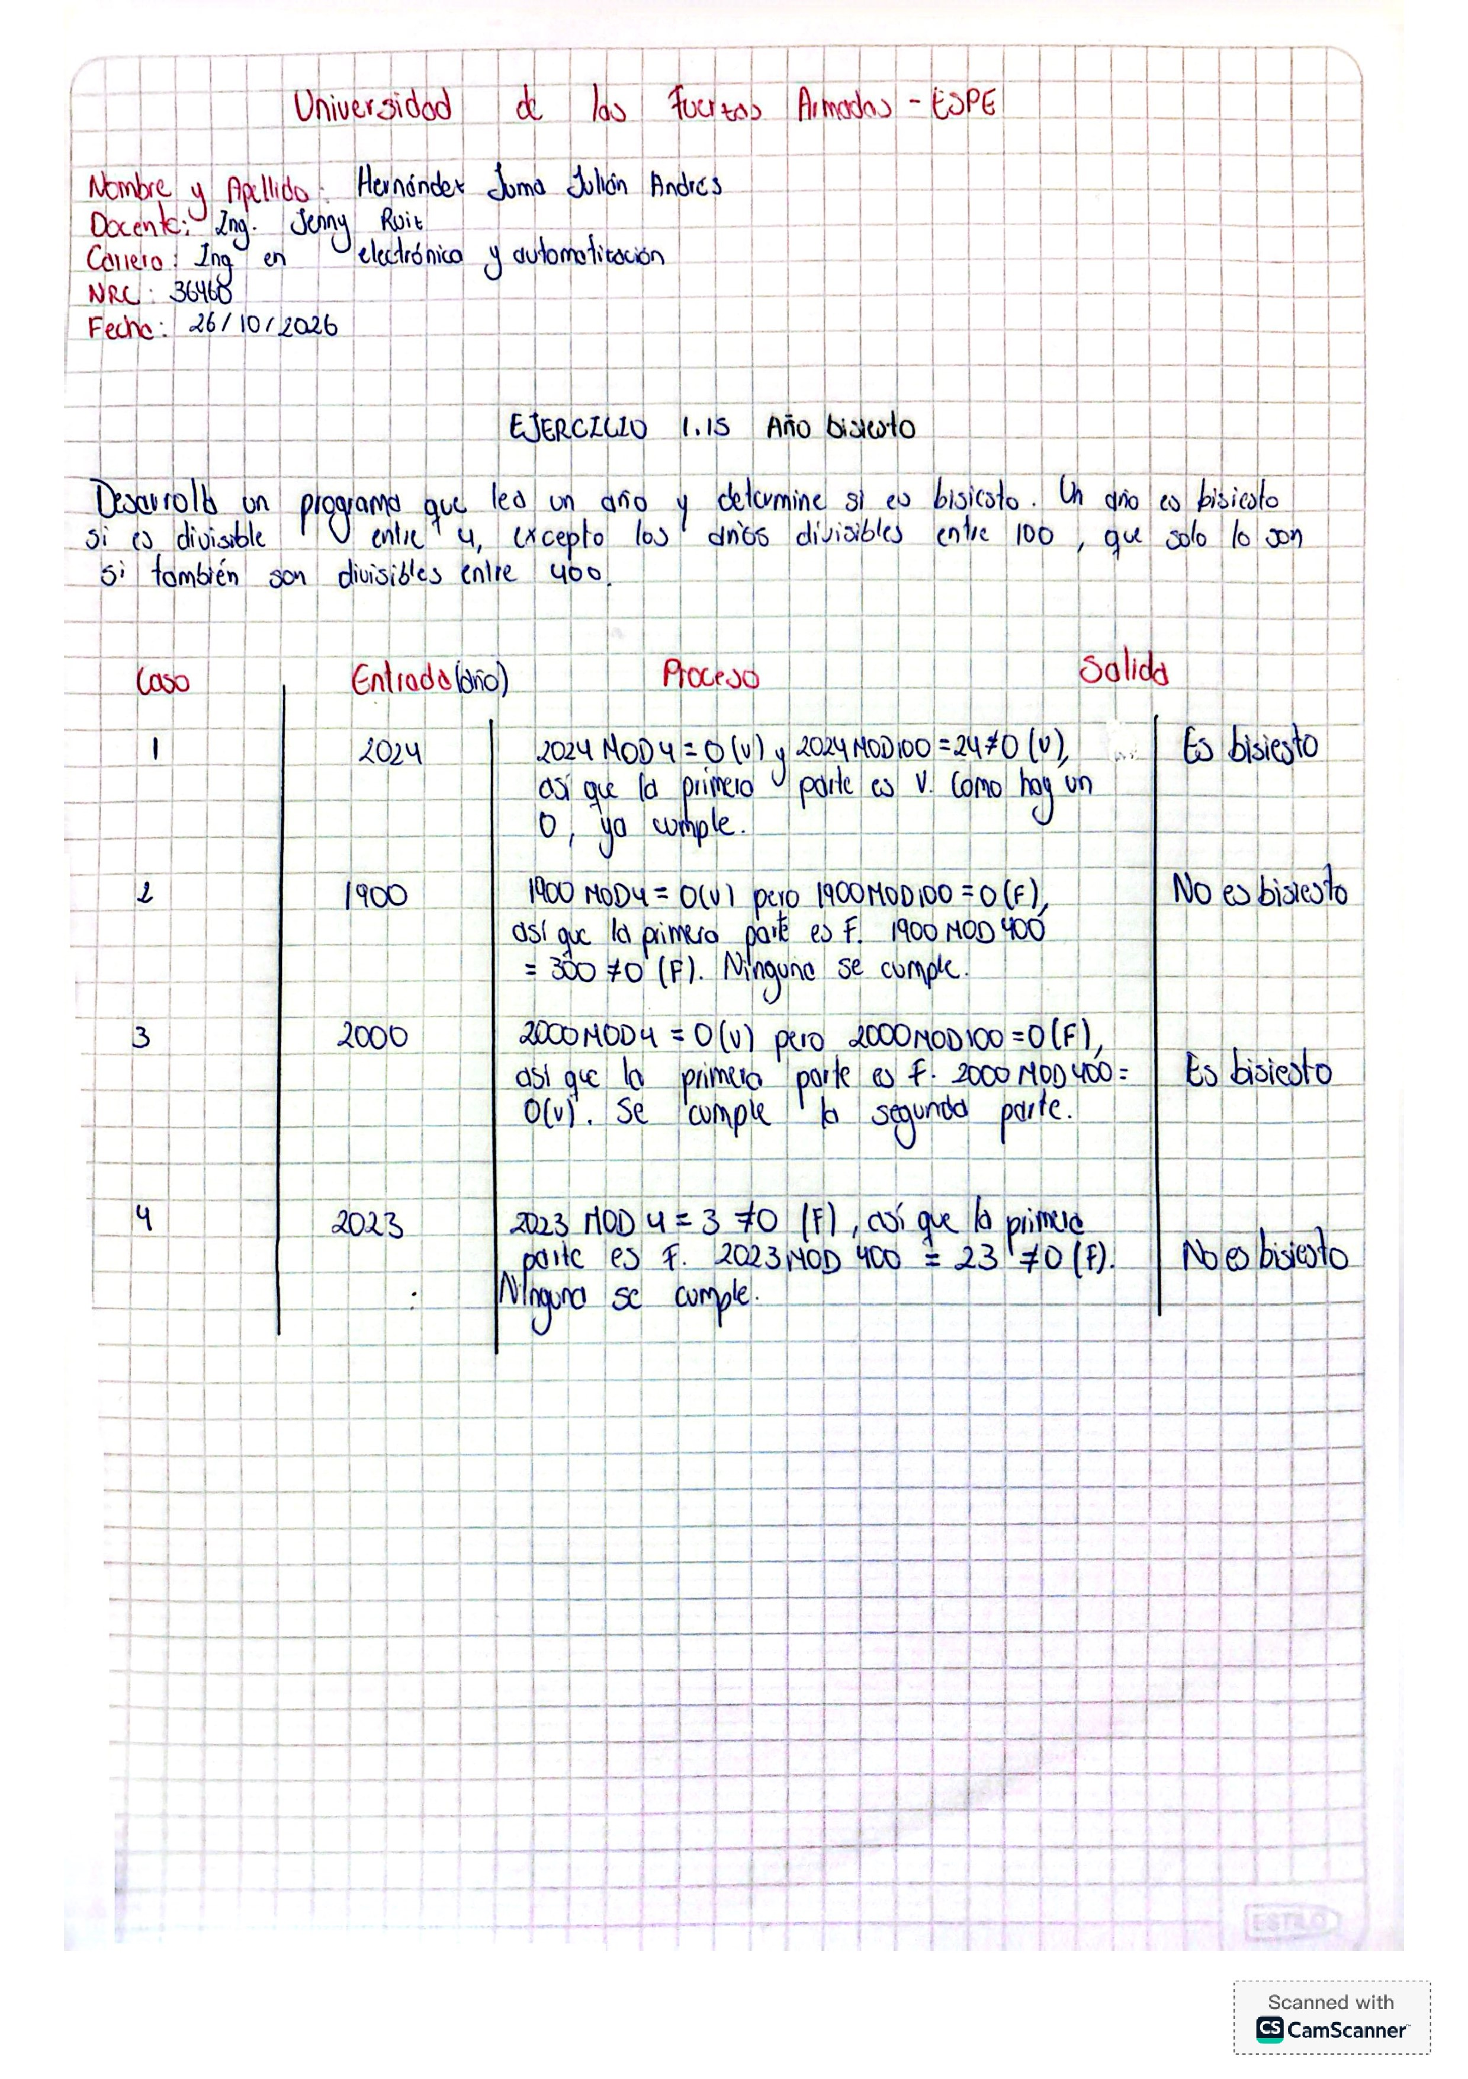
https://onlinegdb.com/Q7j5VkGON

